**Please Note:** User needs to install the RSA SecurID app on the Phone before proceeding to User Instructions below. To install RSA SecurID App, please

* Tap the App Store\Google Play icon on your Phone.
* Select Search and enter - **RSA SecurID App**.
* Select the RSA SecurID app and install it.
* Once installed and active the app will not require network/Internet access to provide a code.

User Instructions

1. Go to <https://rsa.web.rbsgrp.net/ssp/>, type in your user id and the 4 digit PIN that has been provided to you by ~ Security Services Operations RSA India team. Click 🡪Log On.

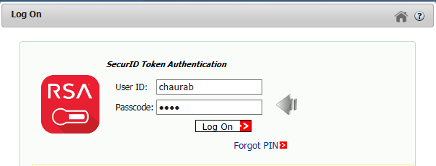

1. Set a new PIN, re-enter the New PIN and click 🡪 Log On

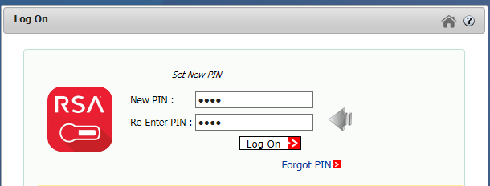

1. Type in your new PIN and click 🡪 Log On

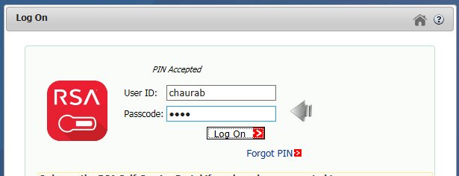

1. This will send you an email to your work email address with **Your On-Demand Tokencode**

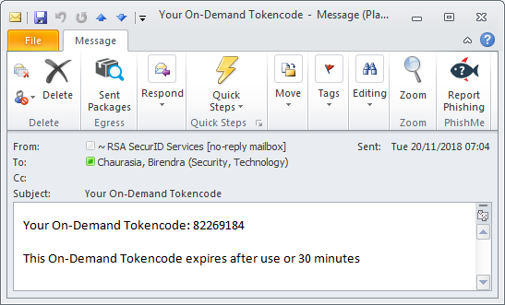

1. Copy & Paste **Your On-Demand Tokencode** into the “**Next Tokencode Required**” field and click 🡪Log On

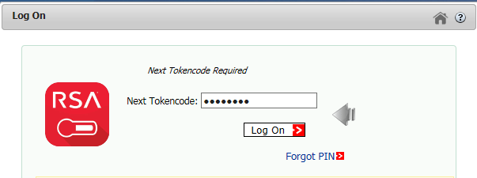

1. Please enter your Europa Domain password and click 🡪Log On to import the soft token

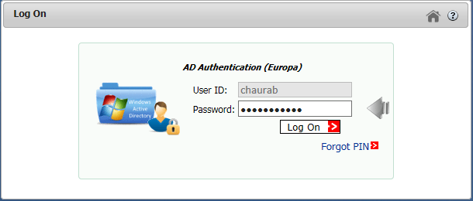

7. The RSA Self Service page opens as below with available tokens if already assigned to user.

Token number 505705600 is already assigned to user (Here).

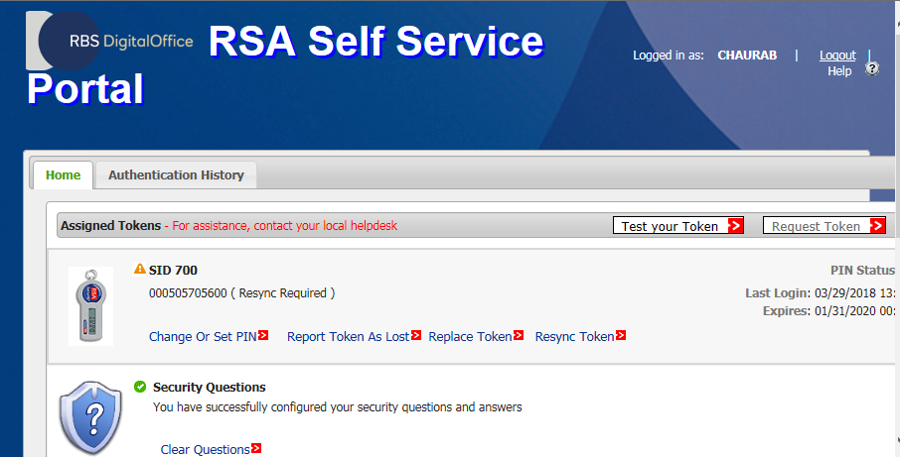

8. User already has any RSA token assigned Click 🡪 **Replace Token** (Figure below)

In case user does not have any RSA token assigned – Click 🡪**Request token**.

9. Once clicked on 🡪 **Replace Token**, the page appears as below.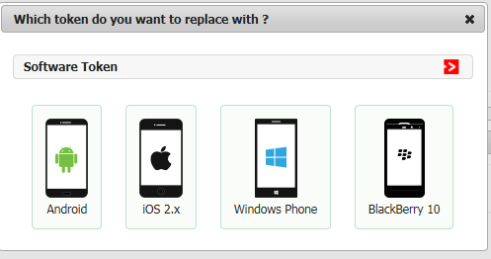

10. Select your device type (Android here), and set New PIN (Never user before) click Submit

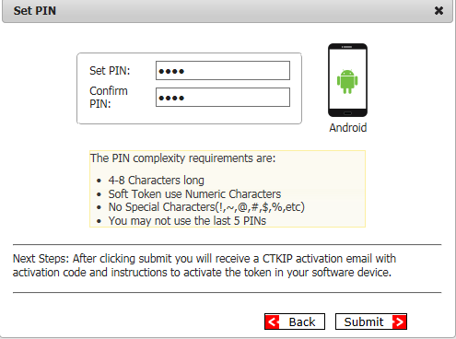

11. The below screen appears, click 🡪 **Scan Token Now** Tab

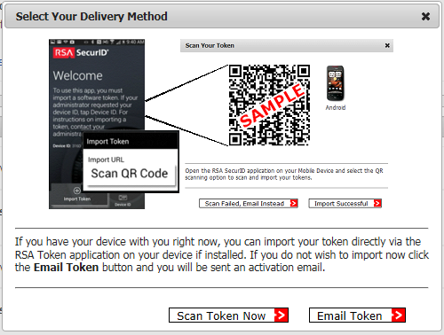

Note: Never click on Email Token Tab as this feature is currently disabled.

12. Scan the below QR Code now using Scan QR Code available under Import Token of RSA App

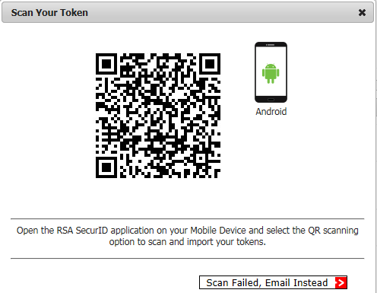

13. Once the token is scanned successfully, **Import successful** message is prompted on the portal as below. Click OK.

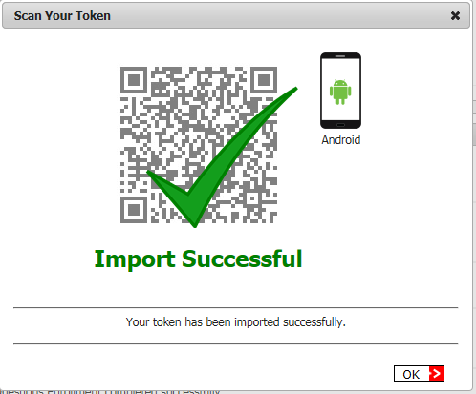

14. Test your token using the PIN (PIN set in STEP 10) +6 digits from the RSA App. If you encounter the below Authentication Success message, your login is successful. Going forward, always use the PIN (PIN set in STEP 10) +6 digits from the RSA App to login.

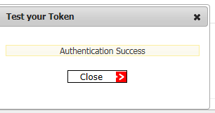

For RBS Connect Go to <https://rbsconnect.rbspeople.com> and for any Application\system logon page: 🡪 Enter your Europa ID, Europa password and PIN + the 6 digit token code.